Project Plan

<Victoria State Accident>

Eddie Thompson s5282264

Fletcher Bradley s5292215

Kei Giliam s5270448

Assignment Groups 130

Table of Contents

1.0  Introduction 2

1.1   Background 2

1.2   Scope 3

1.3   Document contents 4

2.0  Work Breakdown Structure 5

3.0  Activity Definition & Estimation 8

4.0  Gantt Chart 11

# 1.0  Introduction

## 1.1   Background

This document is a project planning for displaying all data, visual charts, search keywords, and analysis in categories from a database. The database is a dataset of Victoria State Accident Dataset. [1] This dataset is –. The road safety data is provided by VicRoads. [2] The dataset includes;

* Object ID
* Number of accident
* ABS codes
* Whether accident reopened or finish
* Accident date
* Accident time
* Whether accidents affected by alcohol
* Type of accident
* Day of week
* Reason to get accidents

Etc. (63 different columns)

This project is for improving road safety of users to retrospective review of the data to understand road safety and accident threads.

## 1.2   Scope

This project runs 10 weeks (including 1 week off) 4/8/2023 to 08/10/2023 (week off on 14/8/2023 to 20/8/2023).

The milestones are divided by 2 parts:

4/8/2023 to 3/9/2023

* Pre-Plan Document
* Prepare Project Plan Document
* Prepare Software Design Document

4/9/2023 to 8/10/2023

* Developing
* Testing

Data inclusion (columns):

* Object ID (OBJECTID)
* Number of accident (ACCIDENT_NO)
* ABS codes (ABS_CODE)
* Accident date (ACCIDENT_DATE)
* Accident time (ACCIDENT_TIME)
* Whether accidents during standard trading hours (ALCOHOLTIME)
* Type of accident (ACCIDENT_TYPE)
* Day of week (DAY_OF_WEEK)
* Reason to get accidents (DCA_CODE)
* Light condition (LIGHT_CONDITION)
* Whether accidents affected by alcohol (ALCOHOL_RELATED)

Data exclusion (columns):

* Whether accident reopened or finish (ACCIDET_STATUS)
  + The result is 100% finished
* Number of males (# MALES)
* Number of females (# FEMALES)
  + Both genders numbers are similar
* Number of unlicensed drivers (# UNLICENSED)
  + The number is almost 0

This project aims to create visual data software by charts and tables, using the Victoria State Accident Dataset as resources. [1]

The risks and threats of this project is loss of data. Keeping backup of this data will avoid the risk.

## 1.3   Document contents

This project document contains several documents;

* Project Plan.docx: This document which is detailed of the project plan.
* Gantt chart.xlsx: Gantt chart of this project.
* Software Design Documant.docx: details of design of this project software.
* Software Testing Report.docx: details of testing built software.
* Exclusive Summary.docx: summary document of this project.
* git_log.txt: the communication log of this project.
* time log.docx: worked date and approximately time log this project member has spent.

There are several software and applications this project uses.

For creating documents and communication: Microsoft Office Word, Microsoft Office Excel, GitHub, Git Bash, Git Flow Chart.

For developing: Anaconda Prompt, PyCharm, Jupyter notebook, Microsoft Office Excel, WXFormBuilder, SQLite.

For resources: Victoria State Accident Dataset. [1]

# 2.0  Work Breakdown Structure

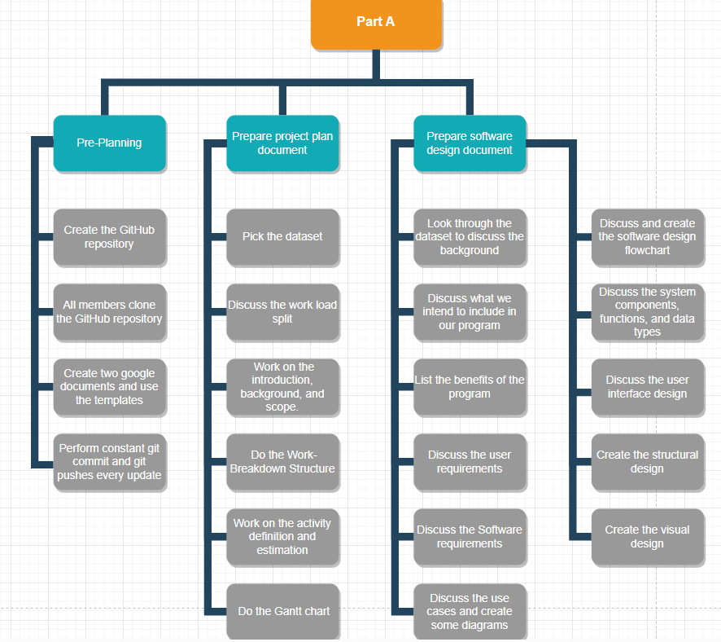**Figure 1: Work Breakdown Structure Part A**

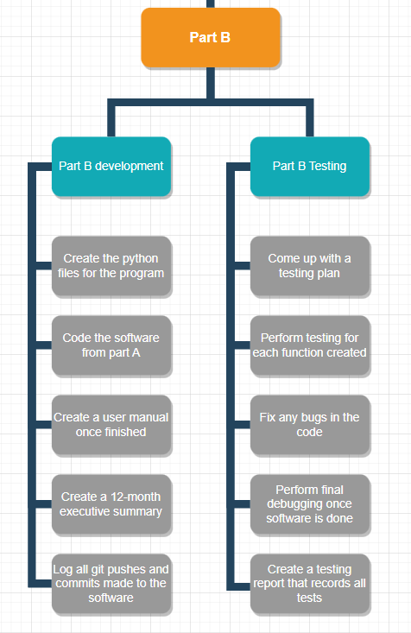

**Figure 2: Work Breakdown Structure Part B**

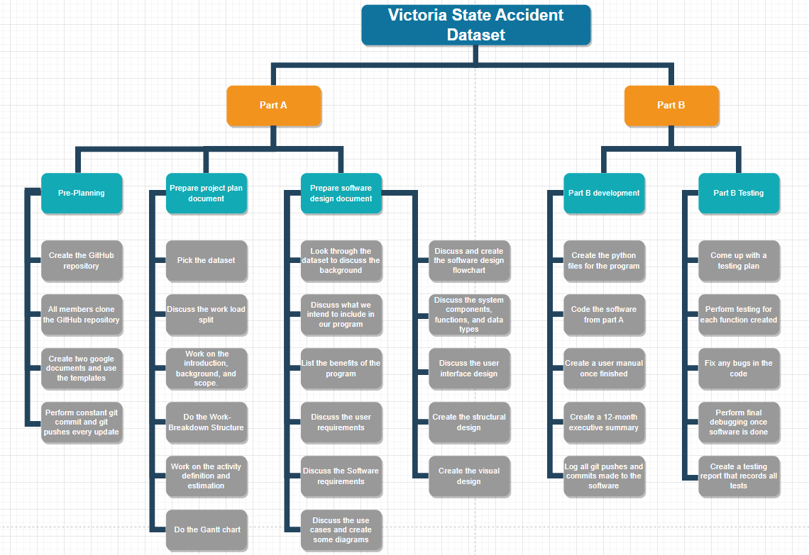

**Figure 3: Full Work Breakdown Structure**

# 3.0  Activity Definition & Estimation

**Pre Planning**

1. Create the GitHub Repository: One member will create a GitHub repository using the given files from the assignment overview. Estimated time: 1 day.
2. All members clone the GitHub Repository: Each member will clone the GitHub Repository onto their own machines so they can commit and push updates made. Estimated time: 1 day.
3. Create two google documents and use the templates: One member will create two google documents using the templates given, one for the project plan document, and one for the software design document. Estimated time: 1 day.
4. Perform constant git commit and git pushes every update: All members will use git commit and git pushes to update the remote repository every time the document has been updated. ETA: 10 weeks.

**Prepare Project Plan Document**

1. Pick the dataset: As a group, we will decide which dataset to base our assignment on. Estimated time: 2 days.
2. Discuss the workload split: As a group, we will discuss what each member will do for the assignment. Estimated time: 1 day.
3. Work on the introduction, background, and scope: One member will focus on doing the introduction, background, and scope for the project plan. Estimated time: 3 days.
4. Do the work breakdown structure: One member will work on the work breakdown structure diagram in draw.io. Estimated time: 3 days.
5. Work on the activity definition and estimation: The member who worked on the work breakdown structure diagram will also list and describe the activity definitions and estimations that were listed in the WBS. Estimated time: 2 days.
6. Do the Gantt chart: The member who worked on the WBS and activity definition and estimation will complete the Gantt chart based on the information in the activity definition and estimation and WBS. Estimated time: 3 days.

**Prepare Software Design Document**

1. Look through the dataset to discuss the background: As a group, we will look through the dataset to find more information about the raw data and describe it in the background. Estimated time: 1 day.

1. Discuss what we intend to include in our program: As a group, we will discuss what features we want our program to be able to do on top of features that are required. Estimated time: 1 day.
2. List the benefits of the program: As a group, we will discuss and list the benefits that our program will give to the users. Estimated time: 1 day.
3. Discuss the user requirements: As a group, we will discuss and list the user requirements that we expect are needed for our program. Estimated time: 1 day.
4. Discuss the software requirements: As a group, we will discuss and list the software requirements that are expected when using our program. Estimated time: 1 day.
5. Discuss the use cases and create some diagrams: As a group, we will discuss the use cases of our program and one member will design the use case diagrams. Estimated time: 3 days.
6. Discuss and create the software design flowchart: As a group, we will discuss the software design and one member will design the flowchart that showcases the software design interactions. Estimated time: 2 days.
7. Discuss the system components, functions, and data types: As a group, we will discuss and list the functions that we will use in our software, along with the different data structures we will use. Estimated time: 4 days.
8. Discuss the user interface design: As a group, we will discuss how the user interface should be designed and what needs to be added/improved on the design. Estimated time: 2 days.
9. Create the structural design: One member will create the structural design using an online drawing tool. Estimated time:  2 days.
10. Create the visual design: One member will create the visual design using an online drawing tool. Estimated time: 2 days.

**Part B Development**

1. Create the python files for the program: Create all of the python files required for the program to work. Estimated time: 1 day.
2. Code the software from part A: All group members will start coding the program. Estimated time: 1 week.
3. Create a user manual once finished: Once the coding is finalized and fully tested, we will create a user manual that explains how to use the software properly. Estimated time: 1 day.
4. Create a 12 month executive summary: Once all the task analysis has been completed, we will create a 12 month executive summary based on the findings of our program. Estimated time: 1 day.
5. Log all git pushes and commits made to the software: We will log all of the git pushes and commits made throughout the assignments runtime as we continue to make updates. Estimated time: 6 weeks.

**Part B Testing**

1. Come up with a testing plan: Before we start writing code, we will develop a testing plan that will test functions and implementation in our code once they are completed. Estimated time: 1 day.
2. Perform testing for each function created: The group will perform testing every time a new function or implementation is developed. Estimated time: 1 week.
3. Fix any bugs in the code: Once bugs have been identified through testing, the group will fix the bugs until they are completely fixed. Estimated time: 1 week.
4. Perform final debugging once software is done: Once the software is fully completed, the group will do one last wave of debugging to make sure everything runs smoothly. Estimated time: 3 days.
5. Create a testing report that records all tests: The group will create a testing report that will have the dates of each test performed, as well as information on what was tested. Estimated time: 2 days.

# 4.0  Gantt Chart

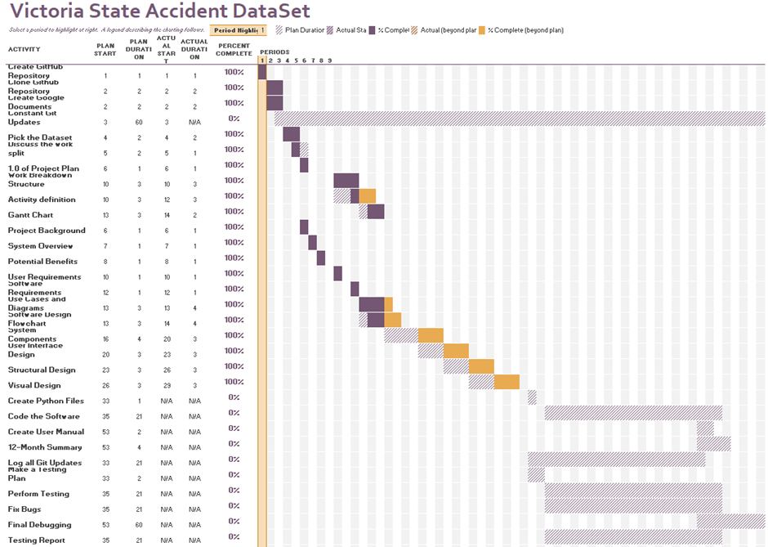

# Reference

[1] G.Chauhan, “Victoria State Accident DataSet”. Kaggle. <https://www.kaggle.com/datasets/gaurav896/victoria-state-accident-dataset> (accessed Aug. 31, 2023).

[2] Victoria State Government, “Safety & Road Rules”. Vicroads. <https://www.vicroads.vic.gov.au/safety-and-road-rules> (accessed Aug. 31, 2023).